Dec 24, 2025

Tags: Python, SQL, revenue, AWS, AWS Data Engineer, Data Engineer, Kepler.gl, kepler, WebGL, DASK, quicksight, Quick Suite, aws wrangler, xarray, Athena, NetCDF, illumon-iris, SciTools Iris, s3fs, HDF5, h5netcdf, h5py, netcdf4, pyarrow, iris, cartopy
NOTE: this is not fully detailed content but enough for a reader to understand.

Data Engineer Take Home Project for AWS
Project Background 3
Project requirements 3
Sample Code 4
PIPELINE 5
NetCDF data 6
Cube-based visualization 7
Project – Initial Thoughts & Business Use Case 8
Data 9
Costs 10
AWS Tools / Services 11
AWS IAM Permissions 11
Configurations 12
Glue Python Shell is a better move 12
Kepler.gl 12
Project Errors & Issues 15
Previous Tech Roles Encountering Errors 15
NOTE: 15
AWS Cloudshell 16
Code Conflicts/Issues – HDF5, h5netcdf, h5py, netcdf4, pyarrow, iris, scitools-iris 16
Cause of ‘some’ conflicts: 17
File name Time issue 18
Glue Script Editor issue 18
Glue Python Shell issue 18
Glue DPU issue 19
My Background 20

Also on Github: a Word doc (same name) and a Readme file.

Project Background
Let’s mosey on over to the project background…
Yes, a wee bit of humour here, I do not ever undertake writing a stiff, formal document, even while in college (well, for a few classes I did).
The story goes as:

Project requirements
At Big Wind LLC, we provide timely analytics related to weather data to our customers.
One of our leading solutions allows our customers to query high-resolution weather forecast data that is provided by the UK Met Office. This solution provides these core capabilities to our customers:
- High availability
- Quick response
- Timely availability of new data
Because of the significant financial losses they would incur, our customers cannot accept any downtime. Our solution provides them with the data they need to plan and the flexibility to make sure downtime does not occur. For example, airport and airline operators use our solution to plan their flights or predict delays caused by weather.
Goal
You are tasked to provide reporting and dashboard access to the forecast data with AWS QuickSight so that Data Analysts can query the data and show the data insights in tabular format.
In this exercise, you will design, implement, and showcase the secured and scalable data pipelines that ingest, transform, and support visualization of the data in AWS QuickSight. All new data should be available to the Data Analysts as fast as possible.
You can choose any variables in the dataset to support one or more business use cases of your choice. For example, your dashboard could focus on airport operators and report the forecast on specific variables used by airline operators (dew point, air temperature, wind speed) during takeoff.
Data
Your solution should use the MOGREPS-UK dataset and assume that the files are available in .nc (netCDF or Network Compress Data Form) format every few minutes with 20–30 MBs of data.
We can access the dataset using the AWS CLI (AWS Command Line Interface), for example, using the following command to list all the available files in that bucket:
- aws s3 ls --no-sign-request s3://mogreps-uk/
The ‘—no-sign-request’ signifies the s3 bucket as a public bucket with no additional access requirements.
Each file contains weather forecasts that predict variables such as air temperature, humidity, and rainfall. Each variable is predicted for these dimensions: latitude, longitude, altitude (when applicable), pressure (when applicable), and time.
Latitude and longitude values use a RotatedGeogCS coordinates system. Time is stored as number of time periods (for example, hours) since epoch.
You may use libraries such as Iris to explore the file contents, but, make sure to note the library and dependencies size when you deploy it to production. The Sample Code section includes a code sample to help you explore the file contents. Distributed frameworks also have libraries that support netCDF manipulation.
Compute
Build the solution using AWS services. You can use any services or frameworks that show our core capabilities, security, and cost effectiveness.

Sample Code
### To install iris, install conda and run “conda install -y -c conda-forge iris”
import iris
filename='prods_op_mogreps-uk_20140717_03_11_015.nc'
#Load the list of cubes. See [3] in the links section for more details
listofcubes = iris.load(filename)
print(listofcubes)
#Extract one cube, air_temperature measure in Kelvin. See [3] in the links section for more details.
cube=listofcubes[8]
print(cube)
#Number of dimensions for the time coordinate
cube.coord('time').points
#Number of dimensions for the pressure coordinate
cube.coord('pressure').points
#Number of dimensions for the longitude coordinate
cube.coord('grid_longitude').points.size
#Convert from kelvin to Celsius
cube.convert_units('celsius')
#Print the cube contents
print(cube.data)
#Get a subset of the data
print(cube.data[0][0][0][0:10])

However, I deviated from that preferred route provided to me. I discovered that, doing Cube workflow to be less desirable. And going with Kepler (free) to be better, for this project at my expense…

PIPELINE
EventBridge (3-min schedule)
↓
Lambda (poll + copy latest .nc) – accessing the correct S3 client (path-style, eu-west-2, unsigned)
↓
S3 RAW bucket (NetCDF) – bringing the latest netCDF forecast file down to my s3 bucket
↓
Glue Python Shell Job (NetCDF → Parquet + CSV) – transforming the netCDF files --- xarray is converting the parquet files with partitioned output for QuickSight & Athena / by date
↓
S3 Processed Data – and storing the files into their requisite parquet partitioned folder and/or the .csv folder
↓
Glue Crawlers – Update Glue catalog (database.tables – mogreps_analytics.parq_mogreps_uk) for Parquet & CSV. This is for Athena SQL views and other queries to be carried out
↓
Athena Tables + Views
↓
Athena UNLOAD (sampled CSV) – to reduce the monster file down to a smaller subset
↓
Kepler.gl Visualization – original plan was to feed QuickSight – but nixed that due to unwilling to pay for the enterprise pro version, replaced with Athena & Kepler --- this is in using .csv exported files (using SQL unload) from mogreps_kepler_sample_10pct (the smaller, sample datasets)

NetCDF data
This project was to pull down .nc (NetCDF – network compressed data form) files from the UK MOGREPS server, which as I discovered is in reality, now under AWS purview. Throughout my entire tech career, I’ve never touched .nc data. More in my Initial Thoughts & Business Use Case below.

The last step was for AWS visualization, I said to myself – “NO”.
The reason why is because, in order to view the resulting transformed files, you will need to use multidimensional scientific array software for these meteorological data points. You are thinking, ‘yes’, Quicksight for visualization. You are correct but there is a catch.
The .nc files are approximately 22 MB of condensed data in that multidimensional format. When that one file of data is transformed, it becomes a 6.6 GB monster file.
NetCDF data:
- Self-describing, meaning that a netCDF file includes information about the data it contains, such as when data elements were captured and what units of measurement were used.
- Portable, or cross-platform, in that a netCDF file created on one type of operating system can often be read by software on another type of operating system.
- Scalable, such that a small subset of a large netCDF file can be accessed efficiently without reading the entire file.

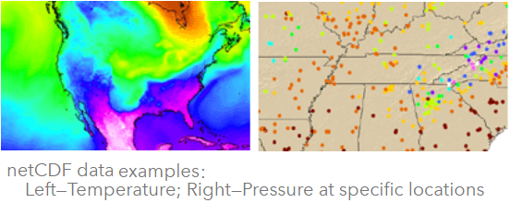
- We cannot use micro$oft Excel because that 6.6 GB is too large
  - Unless we use DASK, in breaking down the data to process (for which I will be making time later to do)
  - DASK – a flexible parallel computing library for analytics that enables users to work with large datasets, including .csv files, that do not fit into memory. It works well for distributed computing, allowing for the efficient handling of large data in a manner similar to Pandas
- And to use aws quicksight (rebranded to Quick Suite), to visualize the multidimensional data:
  - you HAVE to use the ENTERPRISE PRO version, basic quicksight CANNOT handle that data, meaning;
  - you HAVE to pay for the ENTERPRISE PRO version for the Admin / Editor and the users (1);
    - I did not want to pay for one month of Quick Suite to only use it for one — two days (my budget is extremely low since I am living off my savings right now)

  - Instead, I chose to use Kepler.gl, a free multidimensional tool using WebGL (in Firefox it is disabled and I had to figure out how to re-enable it. In chrome and duckduckgo, it is already enabled) – need to ensure you see this image
    - and not this image:
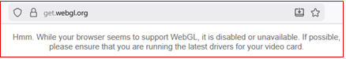

While I did this project, thinking in terms of Latitude, Longitude, Temperatures, Altitudes and flattening the data, there was the other way to do so, per the AWS project parameters. Using the Cube-based visualization method/pipeline.
Why I Didn’t Actually Use Cubes in AWS
Cube workflow  - Research-grade  - Single file  - Local Python  - Matplotlib  - Not shareable | My AWS pipeline  - Production-grade  - Scales to TBs  - Serverless  - Kepler / BI tools  - Analysts can query
Iris does not scale horizontally…
Athena + Parquet does…
Basically, the following ‘appears’ to be a better route
  - Iris → exploration & science
  - Glue/Athena → production analytics
  - Kepler → interactive sharing

Cube-based visualization
One way is to use Iris cubes where we:
  - do not flatten the data
  - preserve dimensions (time × level × lat × lon)
  - Visualize directly from NetCDF structure
Cube-based flow:
✔ Accurate
✔ Fast
✔ Scientifically correct ❌ Not interactive
    - Time–height cross section (very powerful) (Not possible in Kepler)

Project – Initial Thoughts & Business Use Case
Deciding on the business case at the same time, what are we doing?
We need to obtain global meteorological data from a trusted source. Here, that would be MOGREPS-UK (Met Office Global and Regional Ensemble Prediction System) office. This office was designed to aid the forecasting of rapid storm development, wind, rain, snow and fog. But, the MOGREPS-UK is for the local UK region that this personal project was assigned. There is a MOGREPS-G office for “Global” forecasting, but not used in this case. Per the MOGREPS office, their ensemble of the model parameters (temperature, pressure, wind, humidity, etc.) are forecast at grid points separated by about 2.2 km, and the model has 70 vertical levels.

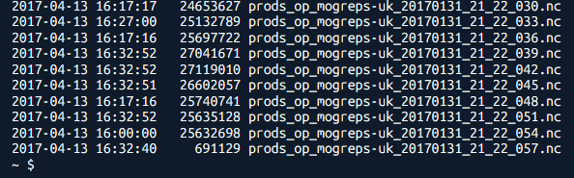
MOGREPS stopped updating that data in 2017, the last tranche of files is all 2017. Next, we have to transform the data and load it into storage using AWS services only. NetCDF is data that I’ve never worked with before but now know a lot more about…
As you can see in this one snippet, there are multiple .nc files (Jan 2017) showing.
If you were to do the CLI command (above) via a Cloudshell terminal – you will see page after page of .nc files – but it will take some time for all the pages to scroll by.
Pressing and holding the space bar helps speed it up…

The .nc data looks like any of the following with multiple dimensions:
- Climate/weather data: (time, latitude, longitude, altitude)
- Ocean data: (time, depth, lat, lon)
- MOGREPS data: (forecast_step, lat, lon, variables)
---- or ----
- latitude × longitude × time
- pressure_level × latitude × longitude
- ensemble_member × time × variable
- or any N-dimensional grid
America, east coast:  lat BETWEEN 49.5 AND 55.5  AND  lon BETWEEN -7.5 AND -2.0 | England, west coast:  lat BETWEEN 25 AND 45  AND  lon BETWEEN -80 AND -65
But since we’re dealing with MOGREPS-UK, we’re only looking at the UK local region data and not American data points.
This allows weather agencies (i.e.: Met Office, NOAA, ECMWF) to publish forecast and re-analyze data in NetCDF.
The key point is, you must know what latitude and longitude you would be working with, such as for:

The MOGREPS-UK bucket, is a legacy AWS S3 bucket, as mentioned earlier – under AWS purview, and the data in that s3 bucket spans, it appears, only to 2017…? OVER 47,000 files (somewhere in that ballpark).
**** What region is that bucket in? **** need it for the correct IAM permissions…
It is in AWS eu-west-2.
Who is the data for? Experienced Analysts? Mid-level Analysts? Junior Analysts? Executives and/or Directors who want to know in order to direct their business strategy? In this scenario, it is for Analysts.
How rapidly is the data needed, daily, hourly, in minutes – continually? In this case it is to be obtained every 3 minutes, if there are updates.
Which component of the data are we focused on primarily? Need to view the data because there are 39 variables in each dataset. And the datasets are ~ 22 MB .nc files (NetCDF – network compressed data form) compressed files but when expanded for analysis, that could balloon into approximately a 6.6 GB file to work with. And understanding what a netCDF file is about, that can be an arduous task. Working with Latitude, Longitude, Temperature, Altitude, Fog, Humidity, etc.…
The very first time through, the thought was to check out the data as to how raw the unstructured data is & how much EDA is needed. There is more on the data, later on.
Scan the source contents to determine whether there is EXTRA content in the source that we need to avoid doing any processing on.
Think about what kind of pipeline we are going to use – processing solely on Lambda or download and transform (maybe using Glue) into either .CSV files or CSV & Parquet files.
ETL or ELT…
And lastly, how to present the data for visualization.
NOTE: AWS Step Functions was considered but this was not a complex enough project to pull in this AWS service. The cost of Step Functions but it still adds up, especially if there were constant new .nc files to poll and pull down for processing.

Data
Data is already clean, just have to use it in the manner we desire / need for usage.
But. MOGREPS does state that – there are several sources of uncertainty in weather forecasting which can cause errors in the forecast, including:
- the starting conditions
- the forecast model
Everyone needs to keep that MOGREPS statement in mind.

EDA scikit-learn; numpy; pandas; OHE (one hot encoding – to do binary trick, yes or no values [0 or 1]); MICE (Multiple Imputation by Chained Equations) usage maybe. EDA is not necessary for these datasets – but still need to be checked anyway...
Pandas and Numpy are being used.
Data is already clean; it is just old data. OHE is definitely out, what with the 39 variables/columns of data and millions of rows of data (10s of millions to 100s of millions of rows…).
The MICE method will not be necessary, no missing data, not across multiple columns.
And, ETL, that is the method I’m going with here.

Zip file for the .py package did not work, too large for Lambda (128 MB, I chose not to increase memory size)
--- switched to Docker container
Will it more beneficial to do Lambda transforms: from netCDF to .JSON and/or CSV and THEN to parquet --- If so, will need two Lambda functions (or just one)
Or just go straight from .NC to .parquet – do we need the .CSV files?
Because if we want the entire file, it will be transformed to a 6.5 GB file. Whereas with .parquet files, they will be transformed into groups of ~14.5 - 22 MB .snappy.parquet files.
The reason for the ~6.5 GB .csv file is due to geospatial/multi-dimensional points:
- i.e.: 548 lat × 421 lon × multiple time × multiple levels, etc. 20170131
The original s3://mogreps-uk/*.NC files are ~22-28 MB (prods_op_mogreps-uk_20170131_21_22_057.nc).

When Lambda is executed and there is no newer file to extract, then it goes back to sleep with nothing else to do. The Glue and Glue Crawlers never fire up.
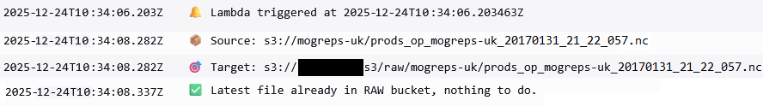

Costs
Yes, budget talk time. A very critical piece and I have seen this while at one of the intelligence agencies when I was appointed to have all divisions, from the directors on down, using AWS cloud to clean up excess use:
- using standard S3 buckets for long-term storage
  - petabytes of data were moved or deleted, saving some very serious revenue
- unused services and tools – EC2 instances and Databases
  - massive overuse of EC2 instances and other services that were not needed, i.e.: P3 servers when, at the time, M3s were okay
- ensuring that the division chiefs/leads were using Cost Explorer, Billing and Cost Management and Budget alarms – many were not
  - wound up creating very explicit powerpoint slides for some of the leaders – many of whom did not talk to their own AWS Cloud Architects – embarrassment…??? I did not ask, just showed them how.
COST IS CRITICAL and everyone has to be mindful before it runs away, eating up budgets.
In this scenario, in pretending to be the Managing Director, I wanted minimum cost, seeing how this was on my own dime.
I used minimal AWS tools/services to meet the objective of producing usable multidimensional data for analysis and projections. The last step of using Quicksight was out of the question, more on that below. Using Kepler.gl as the substitute was the alternative.
As such, I incurred minimal costs. But I did switch to a smaller dataset download, seeing as how that first dataset I created was the 6.6 GB file as noted above. Storage and downloading could add up fast, so I was faster in deleting that from S3.

AWS Tools / Services
What would I want to use out of the following considerations.
AWS Cloudwatch (Logs)
  - MOST INCREDIBLY IMPORTANT TOOL of all here (in my eyes).
  - This is because you HAVE TO track issues and status of everything running in the pipeline / operation.
  - You NEED to see (via print or log function) whether an action took place properly or if an operation died. WHY did it die, OR, what caused it to die?
  - You need to see error codes and the explanation (and if the code/explanation is too cryptic — then go dig in and research what the error code/explanation really means)
AWS Wrangler (awswrangler / WR), boto3
Other applications/imports:
- Python, pandas, SQL, Docker, xarray, s3fs, pyarrow
were all used or attempted
AWS CLI (cloudshell terminal):
- Profile information set, to get the terminal set up for any/all usage
- Docker logged into (for any container usage – which I had used but ceased)

AWS IAM Permissions
- Admin of course.
- Along with one test case user that only has Quicksight and Athena rights.
- Lambda with:
  - Trust relation for Lambda to assume roles;
  - Allow Lambda to start Glue / Glue Crawlers;
  - Create logs
- Glue / Glue Crawler – AWS managed service role for multiple needs of Glue
- S3
  - mogreps-uk bucket, no permissions needed, it is set as publicly accessible, but set permissions so Lambda function can access it
  - Lambda function was allowed to access all S3 buckets of my account – to list, get or put
S3
- Multiple buckets, for the original .nc file; bucket for .csv file(s); bucket for parquet (partitioned) files
- Along with s3fs to help make it a speedier method
Lambda
Which method is the best route? Using:
- Lamba with .zip files for processing? --- No, multiple crashes, shifted to Docker
- Lambda with docker container (container, Dockerfile, requirements txt, .py file) –- No, multiple crashes; code conflict or dependency issues
- Lambda for polling and downloading without either and do processing with Glue – Yes, this one…
- Eventbridge with one trigger, every 3 minutes to trigger Lambda to poll and check on any new .nc file
Glue & Glue Crawlers
  - allowed to access the mogreps-uk bucket and all S3 buckets of my account – to list, get or put

Athena For creating SQL queries to view data and / or to unload to use as a .csv file to plug into Kepler.
Quicksight This is the ‘No’ that I alluded to earlier. Basic Quicksight, under the rebranded Quick Suite, is not able to work with multidimensional (meteorological) data, we would have to pay for a subscription for the Enterprise version, for – Admin/Editor and for users per month. I decided to skip that and use the free Kepler.gl. The only snag with using the free Kepler version is that we are limited to the size of the data upload to visualize. It is approximately set at.
Kepler.gl To visualize data via the .csv file that is uploaded into Kepler versus using AWS’s rebranded Quick Suite’s Quicksight. There is a size limitation for uploading files into Kepler. It depends on whether we are doing a direct upload (100 – 250 MB) from Chrome or other browsers or if we are doing a URL loading method.

Configurations
The python versions listed below, were the latest versions available for these two sections.
- Lambda – with Python v. 3.14 runtime, python script to do its job and then call Glue and Glue Crawler(s)
- Glue – with Python v. 3.9 runtime, Glue python shell script
- Athena – various SQL queries to satisfy whatever is needed, to begin with

VS Code Yes. Used it with AWS Toolkit enabled and to test various code snippets.
Also, consider using Amazon Q in it for assistance (minor usage to date).

Glue Python Shell is a better move
Now, at first, I did attempt to run Glue using a Spark Glue job but then moved to doing a Glue Python Shell job.
Here are the reasons why I shifted to the Shell job.
Instead of the original (for this project) Spark Glue job, Glue is performed w/a Glue Python shell job:  - Cheaper: Python Shell is ~⅛ the cost of a Spark job for the same runtime  - Faster cold start / simpler: No Spark cluster spin-up, perfect for ~22 MB .nc  - Still using AWS-native ETL (Glue) so it ticks the “AWS tools” box  - Keep exactly the same xarray → pandas → Parquet logic; it just runs in a Python process instead of Spark | Glue Python shell job will still:  - List latest .nc in my RAW prefix.  - Download to /tmp/input.nc.  - Load with xarray.  - Build a DataFrame with:  - lat, lon (wrapped)  - temp_c  - forecast_period_hours (numeric!)  - and any other met fields  - Filter to first N hours (these are the forecast_steps of prediction)  - Write Parquet to processed-data/mogreps-uk/....  - Write small sampled CSV to processed-csv/mogreps-uk/....

Kepler.gl
My flaw here was in using Kepler without the geographic filtering enabled to get America versus Ghana (let alone the UK).
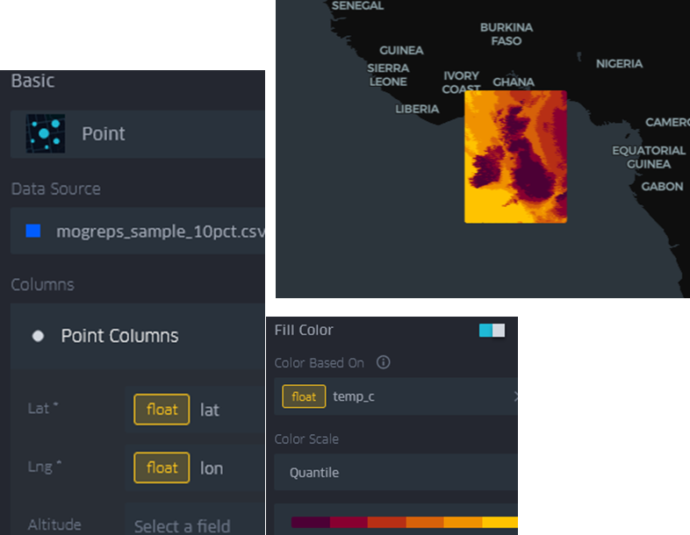
Here is the kepler dataset settings and view for the Ghana (Africa) coastline:

And here are the points I clicked on to get the temp_c and forecast_step.
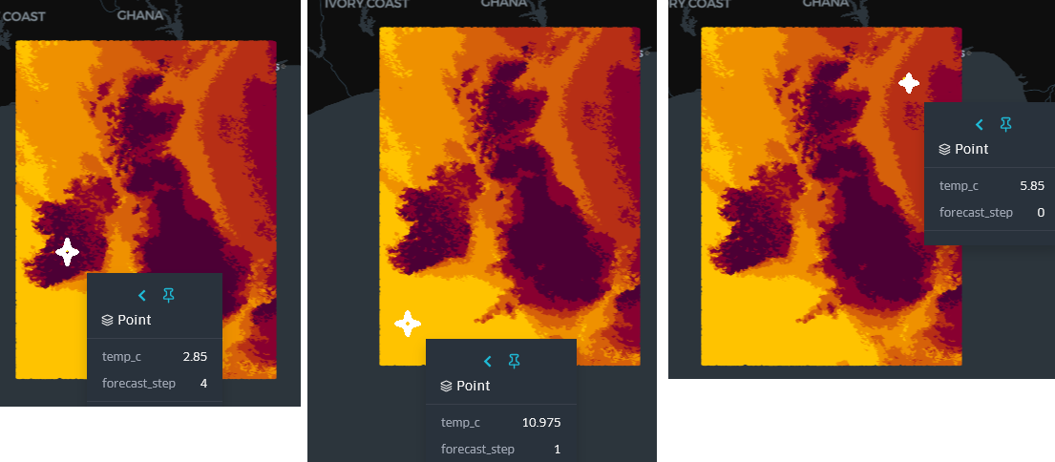

Why the Kepler Map looks like a rectangular "block"
My CSV contains every grid cell from the MOGREPS-UK raster:
- ~550 lat positions
- ~420 lon positions
- 6 forecast steps
- Intensive color quantiles
MOGREPS-UK uses a finite grid covering a rectangular bounding box around the UK, extended a bit outward (for ocean cells).
When rendered as points, this looks like a solid block of color — because there are tens of thousands of points per forecast hour.

Project Errors & Issues

Previous Tech Roles Encountering Errors
This project, it was a tough one, and doing it alone can make any effort very, VERY trying as many folks out there already know. But learning this way has benefits of cooking it into your brain, to a degree…
Various errors such as code dependencies and code conflict were absolutely driving me up the wall. In the past, I never worked with Python, as my primary role and encountering these kinds of code issues.
Say, did I mention that AWS Cloudwatch (to me) is the MOST INCREDIBLY IMPORTANT TOOL of all….?

In the past, being in the tech world for quite a while, I have seen MANY error codes and dependency issues. Errors in the following four (4) areas were encountered when:
I was the Manager / Tech Lead and ran these nationwide teams in parallel:
- Networking (Voice & Data Communications)
- PC Support
- InfoSec / Cybersecurity
- Help Desk
Later, during college, in the Seattle tech world as a senior global tech for a:
- Software emulation company
Later, after college, in the Silicon Valley area, as a:
- Sr Cisco router Engineer (Southwest Bell) – first in the NOC, then in their SOC
- Sr Checkpoint Firewall Engineer (Digex)
and then in the AWS cloud world, as a:
- Cloud Architect / Engineer (Tier II & III)
but this DE Lambda/Python errors and issues area was something else. Totally threw me a curve ball or two. I had to figure these out on my own, some of which I did per my background but others, I had to dig deep in google and even tapping some of the AI systems out there (OpenAI ChatGPT, Duckduckgo, Claude, etc.). And verify that the error resolution is one that works…

NOTE:
For those who solely rely on AI and take those systems’ content verbatim and as gospel, stop doing that.
You have to review EVERYTHING you obtain from those systems prior to using them. i.e.: In SQL, when doing a sampling of data from a large dataset, the use of TABLESAMPLE.
There are two options, SYSTEM and BERNOULLI.
- SYSTEM: Samples at the block/file level (faster, less random but good enough for most cases)
- BERNOULLI: Samples at the row level (slower, more truly random)
And then, with Bernoulli, regarding the percent value, you need to see or know what the parameter is supposed to be. One AI system says to use (10 percent), another says to use (10 %) but the correct parameter answer is (10)… i.e.:
- TABLESAMPLE BERNOULLI (10)
- but you can also use rand() < 0.10 and skip Tablesample altogether……

now on to errors and conflicts.

AWS Cloudshell
Cloudshell terminal was used for checks on data and other configuration needs.
Check to ensure we are doing the extract from the correct region, even though it is under AWS purview, it will
surprise you. For example, addressing using:
- VIRTUAL-HOST style (default boto3) versus
- PATH-style (actual usage) – addressing_style="path" --- or --- s3={'addressing_style': 'path'}
  - it makes a big difference…

Code Conflicts/Issues – HDF5, h5netcdf, h5py, netcdf4, pyarrow, iris, scitools-iris
When I started this project with Lambda, I attempted Zip file uploads. But after receiving various errors, I tried using Docker container for the installs.
Even doing so with the various application installs, Lambda still did not like the application installs within AWS or Python did not like them.
Various application versions, whether it is more recent or older – does not always like to mix in with various versions of other applications being installed. Conflict… Dependency….
If one does not know, it is all trial and error in trying to figure out the best way to use whichever version of application. Applications that will play well with other applications being installed.
Some attempts were errors like:
- Building h5py requires pkg-config unless the HDF5 path is explicitly specified using the environment variable HDF5_DIR (h5py was continually being called in as a dependency) – or;
- h5netcdf 1.2.0 which requires h5py but FAILS inside Lambda (using Docker), even though h5py was not in the Requirements.txt file – or;
- netCDF4 cannot be installed inside the AWS Lambda Python 3.10 AL2023 container image (and trust me when I state that I did a LOT of docker volume / system pruning….) – or;
- iris cannot be installed inside the AWS Lambda – attempt to use with scipy, or use Cartopy instead of iris – or;
- And in using iris, error of: Ambiguous 'iris' package – Please use either:
  - **illumon-iris** – Python integration for Illumon Iris, a time-series database or **SciTools Iris**

Then, will Iris work or will we need to use another Iris version --- like, illumon-iris or SciTools Iris or irisapi
At one early point, I was using yum install for a test run:
In my lambda function (via docker container), I still received this [ERROR] RuntimeError: Ambiguous 'iris' package - causing errors. Program wants me to instead use either: illumon-iris or SciTools Iris or irisapi (question marks below are my input here)
- illumon-iris: a different package possibly(?) tailored for specific use cases
- SciTools Iris: likely(?) the one if we're dealing with netCDF files, commonly used in climate science
- irisapi: might(?) be a web API wrapper for the iris package

Another error received for Iris:
iris import is in .py file and io is in the requirements.txt now I receive this error: 27.81 check.warn(importable) 27.81 /tmp/pip-build-env-y5ssvuzq/overlay/lib/python3.14/site-packages/setuptools/command/build_py.py:212: _Warning: Package 'cartopy.tests.mpl.baseline_images.mpl.test_web_services' is absent from the `packages` configuration. 27.81 !! and this error: 27.81 ERROR: Failed building wheel for cartopy
Thought I needed a yum install for this and received this error:
- it crashed the docker build. But after adding scitools-iris and io, I am receiving these errors:

27.55 If you don't want 'cartopy.tests.mpl.baseline_images.mpl.test_gridliner' to be distributed and are 27.55 already explicitly excluding 'cartopy.tests.mpl.baseline_images.mpl.test_gridliner' via 27.55 `find_namespace_packages(...)/find_namespace` or `find_packages(...)/find`, 27.55 you can try to use `exclude_package_data`, or `include-package-data=False` in 27.55 combination with a more fine grained `package-data` configuration. 27.55 check.warn(importable) 27.55 /tmp/pip-build-env-hv5bn4cs/overlay/lib/python3.14/site-packages/setuptools/command/build_py.py:212: _Warning: Package 'cartopy.tests.mpl.baseline_images.mpl.test_images' is absent from the `packages` configuration. 27.55 Python recognizes 'cartopy.tests.mpl.baseline_images.mpl.test_images' as an importable package[^1], 27.55 but it is absent from setuptools' `packages` configuration.

Cause of ‘some’ conflicts:
Iris + Cartopy + CF-Units require compiled C/C++/GEOS/PROJ libraries, and AWS Lambda Python base image does NOT include gcc/g++ or the system libraries needed to build these packages.
- But still, cannot use Scitools-Iris because it needs iris, cartopy & cf-units

In Lambda’s public.ecr.aws/lambda/python:3.14, none of this exists.
pip is trying to compile these from source → fails → Docker build fails. cannot use the Lambda Python base image and pip‐install Iris.
It is not possible due to the image not providing any of Iris’ binary dependencies.

Remove Iris & Cartopy (& scitools-iris) --- Will xarray work BETTER than Iris…?
I noticed that CloudShell runs on AWS Linux 2023, while Lambda Python container images run on a minimal Lambda runtime that excludes:  - gcc  - g++  - proj  - geos  - shapely  - cython  One area of conflict resolved, not doing some of this effort in Cloudshell… | When pip tries to compile:  - Building wheel for cf-units  - Building wheel for cartopy  - error: command 'g++' failed
requirements.txt 1  boto3  pandas  numpy  scitools-iris  pyarrow  io | requirements.txt 2  boto3  pandas  numpy  xarray  netCDF4  pyarrow | requirements.txt 3  boto3  numpy  pandas  xarray  netCDF4  pyarrow  s3fs

When I was attempting to use Docker container in Lambda, these were the various Requirements.txt files I had, for variations to fix the iris / NetCDF issue:
The end result was using aws wrangler and xarray – without a .zip file or Docker…

File name Time issue
Something I have not seen before, expecting the file name to present as:
prods_op_mogreps-uk_YYYYMMDD_HH_MM_SS.nc
But actual filenames look like this:
prods_op_mogreps-uk_20170131_21_21_039.nc
↑
NOT seconds but it is in seconds, they (mogreps-uk) padded the seconds w/Zeros…
Instead of: HH_MM_SS the third time component (039) appeared to be a forecast member index, not seconds.
So: "20170131 21" fails this code: datetime.strptime("%Y%m%d %H:%M:%S")
Causing No hours/minutes/seconds in the filename → parser fails → ALL keys skipped → Lambda sees 0 valid files.
Had to strip the leading zero in the three digit seconds and convert it into a TWO digit seconds indicator, all was fine after that.

Glue Script Editor issue
Next, learned the hard way that when we delete the content of the Glue script editor, believing that the advanced properties of the script path with that script file name will be enough, well….. I discovered that is not the case.
What this does, having a blank Glue Script Editor pane, it will take that blank Glue editor content and store that blank (0 bytes) content in the script file – zeroing out the script file content. This leaves nothing in the script path, script file to execute. i.e.: going from, say 7 KB to 0 KB.
Overall, we need the Glue script editor content… and ‘THAT’ will be stored in the script path file…

Glue Python Shell issue
Next, the Python Shell script itself is failing to import because it uses the new | type-union syntax (i.e.: str | None) which is only supported in Python 3.10+.
In this project, as mentioned above, the Glue Python Shell is running Python 3.9, so anything like:
def get_latest_raw_key() -> str | None:
...
raises that error of “TypeError at import time”, before the job even starts.
To get around that error, had to wind up using:
from typing import Optional
and then defining a function helper:
def get_latest_raw_nc() -> Optional[str]:

Glue DPU issue
Glue DPU size is critical, even using a small sampling of the NetCDF file for .csv / parquet transforms, i.e.: the 1/16 DPU will cause the Glue run & Glue crawler cycle to terminate… because of: out-of-memory in Glue
For the glue job run, I was using the AWS Glue recommendation of a 1/16 DPU (0.0625), which is ~1 GB RAM.
And in loading a NetCDF file, pulling ~20 variables, then turning a 548×421×36 cube into a pandas DataFrame – that easily bursts FAR beyond 1 GB. No other choice, either 1/16 or 1… so, the switch to 1 DPU easily solved that issue…

My Background
Okay then, besides the previous tech roles I noted above, I also wanted to share a bit of my background on this Data Engineer (DE) journey.

Finally, I got around to doing and completing my Take Home project AWS previously provided me to move forward for a DE role.
The reason for the project delay was that I had decided to move forward with another company that appeared to be a seriously good prospect – and put this project on a back burner. But….
The company finally decided to ditch me, indicating that I was ‘ONLY’ appeared to be doing “Certification Runs”. And that caused me to write a sizeable paper (~ a 10-minute read) on that specific topic/incident:
- Data / ML / AI Engr Role Denied because Company “Thought” I was ‘ONLY’ doing a Certification Run…
And so, I dropped that prospect and returned to doing and completing this project, just for my benefit – the experience and knowledge of doing it.
It was not to pursue that particular AWS DE role, I had decided to pass on it, primarily because I did not wish to do another 5 rounds of interviews, at one hour each. In 2021, when I was doing Cloud Architect/Engineer roles, I had applied for a similar Cloud role with AWS and went through that process then. It was a failure; I did not have the exact experience AWS was looking for and so, I stayed where I was.
But then I decided to switch over to AWS Big Data (at the time, before it was rebranded to Data Analytics). Another company brought me in for that and I gained that certification, just prior to the Intelligence Community cancelling the contract – deciding to stay with each one’s own data silos…
After that contract cancellation, to remain with the company (instead of being cut) I was moved to a senior cybersecurity role on another contract. It was not AWS Cloud Architect work, so I gave notice and moved on. It was another company for another senior AWS Cloud Architect role.

In 2023, I decided to shift out of my last Cloud role, AWS Cloud Architect Tier III, and shift over to go all in on DE.
I resigned, to take a Study Sabbatical to learn DE. For this, I wrote Journey papers on DE and Machine Learning – same web site.
To be clear, I’ve been in IT for a long time, in the AWS Cloud world since 2014, and then in 2023, dipped my toe into the Google DE world. The GCP Pro DE avenue was a bust – I attempted that effort during a big rash of tech layoffs in the late fall of 2023 (there is another Journey paper on that as well). Then after a month of being sidelined with Covid, I decided to return to continue this DE journey with AWS.

